
Year 2 – Spring 1
Our British Value Focus:
Rule of Law

Help, Help!
Important Dates/Events:

- National Handwriting Day 23rd Jan
- Chinese New Year – Dragon Dancing
- National Storytelling Week 1st-9th Feb
- NSPCC Number Day 6th Feb
- Safer Internet Day 10th Feb
- Children’s Mental Health Week 9-15th Feb
- Pancake Day 17th Feb

Our WOW starter:
Great Fire of London Partake drama workshop
EPIC Ending:
Emergency Services visitor
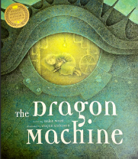
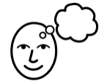
I wonder what The Great Fire of London taught us…
Our focus text in English:

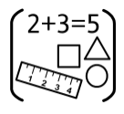
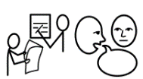
English and Spelling
This half term we will be reading The Dragon Machine. We will be looking at past and present tenses as we write descriptions of what we see as we fly over the Earth in our dragon machine. We will also be looking at adverbs to describe the way our dragon machines work.

In spelling shed sessions we will be learning words where ‘y’ makes an /igh/ sound, words where ‘-es’, ‘-ed’, ‘-er’ and ’-est’ are added to words ending in ‘y’ and words where ‘-ing’ is added to words ending in ‘e’.

Maths

In maths this half term, we will focus on money. We will learn how to make amounts of money in different ways and how to find change.
We will also focus on multiplication and division. We will learn how to draw arrays to help solve multiplication questions and how to group and share to answer division questions.


Computing
This half term our focus will be ‘Robot Algorithms’. We will design an algorithm and find out what happens when we change the order of instructions.
To explain what happens when we change the order of instructions

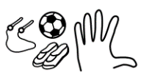
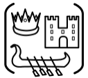
Physical Education
This half term our focus will be on dance. We will be learning different ways of moving and how to link movements smoothly.

History
This half term our history topic is ‘The Great Fire of London’. We will learn about how, when and where the fire started and why the fire spread so quickly. We will also look at what changes have occurred since the fire.
We will take part in a drama workshop acting out the events that occurred.

Home Learning Opportunities:
- Reading weekly at home

- Using Numbots and Times Table Rock Stars

- Using Spelling Shed

- Create a moving vehicle with wheels and axles

- When going to a shop, pay using coins and notes

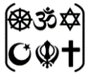
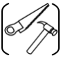
Religious Education
This half term our focus will be on believing. We will learn the Jewish creation story and find out about how and why Shabbat is celebrated.
Design Technology
This half term we are looking at mechanisms. We will learn what wheels and axles are and how they work. We will design, make and evaluate a moving vehicle.

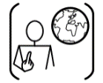
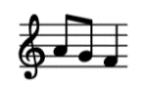
SCARF
This half term our focus will be ‘Keeping safe’. We will identify situations in which to say 'Yes', 'No', 'I'll ask', or 'I'll tell', in relation to keeping themselves and others safe. We will also identify safe secrets and unsafe secrets.

Music
This half term we will be learning the song ‘I Wanna Play In a Band’. We will learn how to play the glockenspiel in time with the song.

